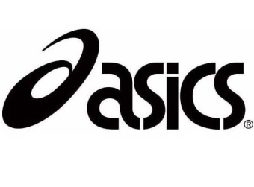

**McNeese State**

**Cowboy XC Stampede**

July 15th, 2015

Dear Coaches,

McNeese State University would like to extend an invitation to your team for this year’s ***ASICS* *McNeese Cowboy Cross Country Stampede***. This is our 10th anniversary of the event. We will have new course this year at the old Pine Shadows Golf Course**. 750 N Goodman Rd, Lake Charles, LA 70615.**

This year’s race will be Saturday, **October 3rd, 2015**

7:00am Course Inspection

8:30am Women’s 5k College

9:15am Men’s 4 Mile College

9:45am Varsity Girls 5K

10:15am Varsity Boys 5K

10:45am Junior Varsity / Middle school Girls 2 mile

11:15am Junior Varsity / Middle School Boys 2 mile

12:00pm Awards

There is $125 charge for College teams. Men / Women $250

Awards will be given to the top two teams. The top 10 individuals in the College Race will be awarded a special edition t-shirt. **Additional T-shirts maybe purchased after the awards for $15.00** **first come first serve**.

If you know your team will be competing please contact our office so we can plan accordingly.

Initial entries are due no later than 12:00pm Tuesday, September 29th via ([www.directathletics.com](http://www.directathletics.com)). For further information checkout our website at [www.mcneesesports.com](http://www.mcneesesports.com).

Yours in Running,

Brendon Gilroy

Brendon Gilroy

Head Cross Country Coach McNeese State University