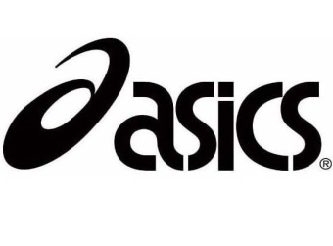

**McNeese State**

**Cowboy XC Stampede**

July 15, 2015

Dear Coaches,

With the start of school brings the opening of the high school cross-country season. McNeese State University would like to extend an invitation to your team for this year’s

**ASICS *McNeese Cowboy Cross Country Stampede***. This is our 10th anniversary of the event. The stampede will also have a new course this year at the old Pine Shadows Golf Course**. 750 N Goodman Rd, Lake Charles, LA 70615.**

This year’s race will be **October 3rd, 2015**

7:00am Course Inspection

8:45am Women’s 5k College

9:15am Men’s 4mile College

9:45am Varsity Girls 5K

10:15am Varsity Boys 5K

10:45am Junior Varsity /middle school Girls 2 mile

11:15am Junior Varsity / middle school Boys 2 mile

12:00pm Awards

The race entry fee is $10.00 per individual for middle and high school.

It will be $50.00 per team Boys and Girls ($100.00 maximum per school). Varsity team will consist of a maximum of seven runners. Additional runners can take part in the Junior Varsity race at no charge. MAKE CHECKS PAYABLE TO **MCNEESE FOUNDATION.**

Awards will be given to the top two teams. The top 15 individuals in the Varsity race will be awarded a special edition t-shirt. **Additional T-shirts maybe purchased after the awards for $15.00** **first come first serve**. Awards will be given to the top five Junior Varsity individuals. Coaches will be responsible for timing their own athletes in the JV race!

If you plan on attending contact our office ahead of time so we can plan accordingly.

[mcneesetrackandfield@hotmail.com](mailto:mcneesetrackandfield@hotmail.com)

Initial entries are due no later than 12:00pm Tuesday, September 29th via ([www.directathletics.com](http://www.directathletics.com)). More information check out our website at [www.mcneesesports.com](http://www.mcneesesports.com).

Yours in Running,

Brendon Gilroy

Brendon Gilroy

Head Cross Country Coach McNeese State University